

**Functional Requirements Specification**

**Intranet Revamp**

**Issue Date: 14/12/2018**



**Document History**

|  |  |  |  |
| --- | --- | --- | --- |
| **Version No** | **Author** | **Change Description** | **Date** |
| 0.0 Draft | Thobiswa Masango and Aubrey Sithole | Document created | 7 November 2018 |
| 0.1 Draft | Thobiswa Masango | Document Updated | 19 November 2018 |
| 0.2 Draft | Thobiswa Masango | Document Updated | 13 December 2018 |
| 0.3 Final | Thobiswa Masango | Document Amended | 08 January 2019 |

# DOCUMENT SIGN-OFF AND APPROVAL

The signatories hereof, being duly authorised thereto, by their signatures hereto authorise the execution of the work detailed herein, or confirm their acceptance of the contents hereof and authorise the implementation/adoption thereof, as the case may be, for and on behalf of the parties represented by them.

|  |  |  |
| --- | --- | --- |
| **SIGNATURE** | **APPROVAL** | **COMMENTS** |
| **_______________________**  **Business Analyst: Retselisitsoe Molaoa**  **Date:………./…………/ 2019** | **Approved /  Not Approved** |  |
| **_______________________**  **Digital Content Specialist:**  **Jackie Van Pletzen**  **Date:………./…………/ 2019** | **Approved /  Not Approved** |  |
| **_______________________**  **Senior Manager Corporate Affairs: Kuselwa Gongo**  **Date:………./…………/ 2019** | **Approved /  Not Approved** |  |
| **_______________________**  **Project Manager:**  **Kim Thomas**  **Date:………./…………/ 2018** | **Approved /  Not Approved** |  |

**TABLE OF CONTENTS**

DOCUMENT SIGN-OFF AND APPROVAL iii

1. INTRODUCTION 6

1.1 Background 6

1.2 Problem Statement 6

2. PURPOSE OF THE FUNCTIONAL REQUIREMENTS SPECIFICATION 6

2.1 Project Scope 7

2.1.1 In Scope Functionality 7

2.1.2 Out of Scope Functionality 7

2.2 System perspective 7

2.2.1 Assumptions 7

2.2.2 Risks 8

3. DESIGN 8

3.1 Design Mock-Ups 8

3.1.1. Intranet Homepage 8

3.1.2 Document Centre 9

3.1.3 SharePoint List View Form 11

3.1.4 SharePoint Document Library View Form 12

3.2 Master Pages 12

3.2.1. Home Master Page 12

3.2.2 Master Page Elements 15

3.2.2.2 Logo 16

3.2.2.3 Search Control 16

3.2.2.4 Mega Menu 16

3.2.2.5 Bread Crumb Navigation 16

3.2.2.6 Global (Top) Navigation 17

3.2.2.7 Content Area 17

3.2.2.8 Footer 17

3.2.2.9 Footer and Logo Links 17

3.3 Page Layouts 18

3.3.1 Layout with Top Navigation 18

3.3.2 Layout without Left Navigation 19

4. SITE TAXONOMY 21

5. SECURITY 79

6. SITE COLUMNS (FIELDS) 80

6.1 Footer Link Category 80

6.2 Display Order 81

6.3 Short Description 82

7. CONTENT TYPES 83

7.1 Linked Summary 83

8. LIST TEMPLATES 84

8.1 Footer Links 84

9. WEB PARTS 85

9.1 Standard SharePoint Web Parts 85

9.1.1. Lists and Libraries Web Part 85

9.1.1.1 List View 87

9.1.2 Document Library View 87

9.1.3. Media Web Part 87

9.1.4. Latest Video Web Part 88

9.1.5. Content Editor 88

9.1.5.1 Content Editor 88

9.1.5.2 Image Web Part 89

9.1.6. Summary Links (Quick Links) 89

9.1.7. Content Query Web Part 89

9.1.7.1 Latest News 90

9.2 Web Parts Created for the ACSA Intranet 92

9.2.1 Mega Menu 92

9.2.2 Footer Links 93

9.2.3 Event Calendar 93

9.2.4 Image Rotator 94

9.2.5. Important Message 94

9.2.6. Announcements Scroller 95

9.2.7. Most Visited Sites 96

9.3 Search 97

10. ANNEXURE 99

10.1 Menu Structure 99

# INTRODUCTION

## Background

ACSA has embarked on a project to revamp the current intranet look and feel with the intent to support the company’s strategy of digitization of processes and, to sustain the adoption and use of the intranet.

The Intranet Stream will deliver the functionality as defined in this Functional Specification document. At a high level, this functionality includes all the content structures (fields, content types, lists and libraries) that are required for the Intranet structure, and the web parts to be used on the Intranet.

In addition, web parts that are not part of the standard SharePoint web part collection that are required by the solution (as defined in this document) will need to be developed and are thus described in this document.

Six site definitions will be created to allow complex, search centre, department and document centre sites to be easily created through a standardised template.

Finally, the styling as approved by ACSA will be implemented and applied to all sites within the ACSA Intranet by means of a SharePoint feature.

## Problem Statement

The current ACSA intranet is designed using legacy technology. The intranet is contained within a proprietary content management system that has limited functionality and is not aligned to ACSA IT Application standards. The proprietary software limits ACSA’s ability to implement best practise with regards to current content management.

As a result, ACSA intends to use its existing technology investment, SharePoint to fulfil this requirement. Within the ACSA environment, there are several cross functional processes that are currently manual, which require automation and for which a large technological investment, or entire application is not feasible for consideration at this stage. The SharePoint technology will allow for the development of these smaller scaled application modules, without the need to make costly technological investments.

# PURPOSE OF THE FUNCTIONAL REQUIREMENTS SPECIFICATION

The purpose of this document is to outline the solution design and functionality that will be configured and developed for the ACSA SharePoint 2013 Intranet site.

The objective of this document is:

* To guide the system developers on what to build.
* To let stakeholders know what they are getting.

## Project Scope

### 2.1.1 In Scope Functionality

Information gathered in this document is based on the Business Requirements Specification Documents for the various ACSA divisions and further information that was collected from the Digital Content Specialist as input towards the designing of mock ups.

Below is a list of divisions upon which the intranet site will be built, in accordance with content provided:

* Supply Chain Management
* Airport Management
* Enterprise Security
* Business Development
* Corporate Affairs
* Transformation
* Corporate Strategy and Performance
* Infrastructure Asset Management
* Technical Services and Solutions
* Company Secretariat
* Information Technology

In addition, content from the Intranet Landing Page Business Requirements Specification Document as well as the Migration document are to be considered in the development of the new Intranet Sites

Business units who’s content has not been provided will be accommodated for; by means of configuring Templates which will act as placeholders onto which content may be populated at a later stage when it is available.

Development will be done in eSoftwares environment and will be deployed to ACSA’s QA environment. The source code will then be provided to the ACSA technical team.

### 2.1.2 Out of Scope Functionality

* Live feed (real time) data i.e. flight information will not be made available on the intranet site, however, link can be provided which would lead the user to a different site where such information can be viewed.
* Upgraded SharePoint installation
* Building/development of eForms has been set for phase 2 of the project, for this current undertaking, iFrames will be configured to enable users to be redirected to the respective webpages/existing custom solutions.
* Redeveloping of existing solutions

## System perspective

### 2.2.1 Assumptions

* A portion of content migration from the old platform to the new intranet environment will be handled by the ACSA IT team
* The SharePoint 2013 environments (Quality Assurance and Production) have been catered for by ACSA and all required access to them has been processed and granted in readiness for development and deployment work.

### 2.2.2 Risks

The current build excludes some divisional content i.e. HR, as the content has not been forthcoming. As a means of contingency, templates will be created for these business units and content can be populated at a later stage when it is available

# DESIGN

During the Envisioning and Planning Phase of the Intranet Stream, eSoftware Solutions created three (3) design mock-ups. During the build phase of the project, only one design will be implemented through the use of master pages, page layouts, and style sheets. In addition to that, five (5) other design mock-ups will need to be created and approved by ACSA as in total, ACSA requested six (6) master pages and 25 page layouts in total.

The branding will be deployed using SharePoint server files and features. This feature will place the necessary master pages, page layouts and style sheets in their appropriate places within the SharePoint infrastructure in accordance to Microsoft best practices.

## Design Mock-Ups

The following design mock-ups have been approved by ACSA and they shall be implemented in the ACSA SharePoint Intranet site.

### 3.1.1. Intranet Homepage

The image below depicts what the intranet homepage will look like.

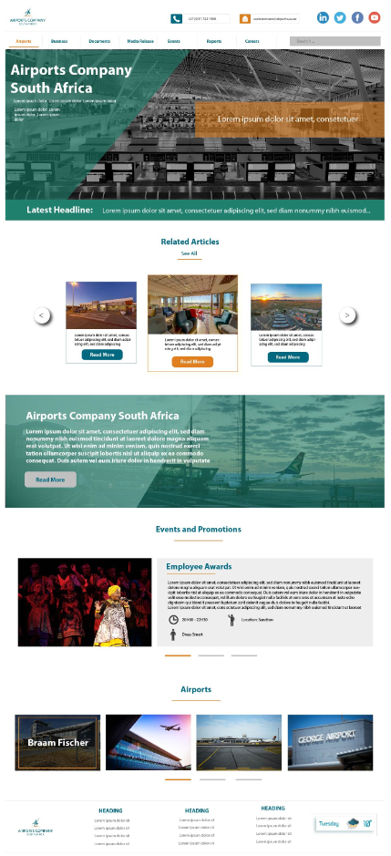

Figure 1 Home Page Design

### 3.1.2 Document Centre

The image below depicts how the document centre will be structured across the intranet.

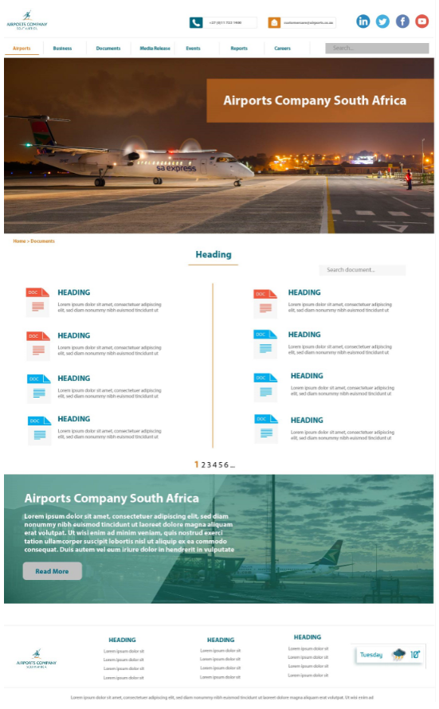

Figure 2 Document Centre Design

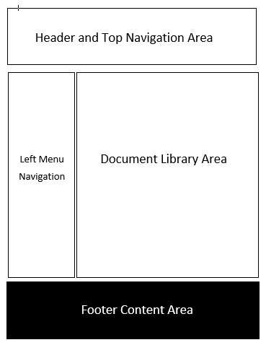

Figure 3 Document Centre Design

### 3.1.3 SharePoint List View Form

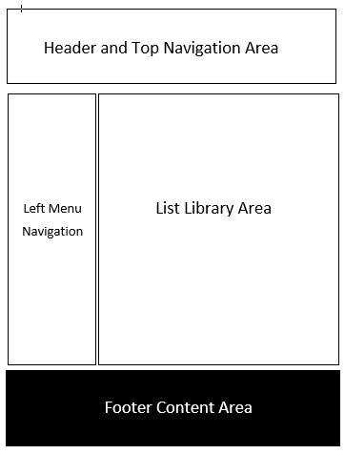

Figure 4 SharePoint List View Form Design

### 3.1.4 SharePoint Document Library View Form



Figure 5 SharePoint Document Library View Form Design

## Master Pages

Master pages apply consistent branding to all pages on a site, thereby helping to ensure that brand assets are correctly used. Master pages allow one to define the layout and common features of a whole set of pages in a single file, providing a much easier and more maintainable route to a consistent look-and-feel. Navigation, footers and headers are commonly included in master pages. Each element is defined in the Master Page Elements section of the document.

### 3.2.1. Home Master Page

The Home Master Page will be used on any page that needs to be aligned to the centre of the screen and has no Global (top site) Navigation requirements, this includes the home page of the intranet.

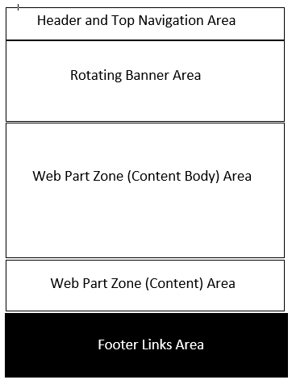

Figure 6 Home Master Page

The red arrow shows the location of the Header of the master page. Just beneath the header is one of the navigation elements of the master page (the top navigation menu).

The green arrow indicates the first of two content areas.

The orange arrow indicates the footer of the master page.

The blue arrow indicates the rotating banner with content of the master page.

The following Master Page elements are used on the Home Master Page (*Master page elements are illustrated in section 3.2.2*):

* SharePoint Ribbon
* Logo
* Search Control
* Mega Menu
* Bread Crumb Navigation
* Rotating image content banner
* Main Content Area
* Footer Content Area
* Footer Logo and Links

#### 3.2.1.1. Sub Home Master Page

The Sub Home Master Page will be used on any page that needs to be aligned to the centre of the screen and requires Global (top site) Navigation. The Complex home page and the Departments home page will make use of the Sub Home Master Page.



Figure 7 Sub Home Master Page

The following Master Page elements are used on the Sub Home Master Page (*Master page elements are illustrated in section 3.2.2*):

* SharePoint Ribbon
* Logo
* Search Control
* Mega Menu
* Bread Crumb Navigation
* Current (left) Navigation
* Main Content Area
* Footer Content Area
* Footer Logo and Links

#### 3.2.1.2. 100% Width Layout

The 100% Width Master Page will be used on any page that needs to use the entire width of the screen and requires Global (top site) Navigation. It will also be used as the system master page. It will be used on pages like:

* The “View all site content” page
* The “Site Settings” page
* The “List View” page



Figure 8 100 % Width Master Page

The following Master Page elements are used on the 100% Width Master Page (*Master page elements are illustrated in section 3.2.2*):

* SharePoint Ribbon
* Logo
* Search Control
* Mega Menu
* Bread Crumb Navigation
* Current (left) Navigation
* Content Area

### 3.2.2 Master Page Elements

Master page elements are components found on a master page.

#### 3.2.2.1. SharePoint Ribbon



Figure 9 SharePoint Ribbon

The standard SharePoint ribbon will be used. The SharePoint Ribbon will be styled as shown in the Design Mock-ups.

### 3.2.2.2 Logo



Figure 10 ACSA Logo

The ACSA Logo will act as a link to the landing page of the homepage of the intranet site.

### 3.2.2.3 Search Control



Figure 11 Search Control

The search control will allow users to search for content, lists, document libraries, list items and documents. The search results that are displayed once this control is used will be dependent on the configuration of the current site collection. By default, the standard SharePoint Enterprise Search centre will be used to display search results, which is how the ACSA Intranet will be configured. The scope of this search is limited to the current site by default. To see more information about the search configuration, please see section 11.

### 3.2.2.4 Mega Menu

The Mega Menu will be used will be used as the Global (Top) Navigation of the site. The Mega Menu will be the primary interface users will use to navigate the ACSA Intranet. To read more about the Mega Menu, please see section 10.2.1.

### 3.2.2.5 Bread Crumb Navigation

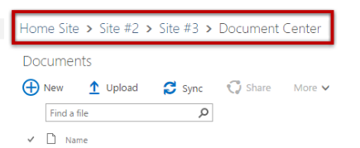

Figure 12 Bread Crumb

### 3.2.2.6 Global (Top) Navigation



Figure 13 Global Navigation

Standard SharePoint Global Navigation (also known as top navigation) is displayed on the top menu side of the screen. What gets displayed in the Global Navigation is dependent on the current site’s Current and Global Navigation configuration.

### 3.2.2.7 Content Area

Content areas are placeholders within the Master page that reserves a space that will be content specific to each page. Such areas may be further defined by the selected Page Layout of a page.

To read more about page layouts, please see section 3.3.

### 3.2.2.8 Footer

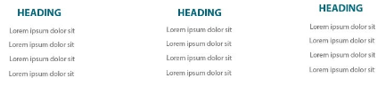

Figure 14 Footer

The page footer has a content area. When a page layout is applied, a web part zone will be placed inside the page footer. The web part zone will be pre-populated with the Footer Links Web Part. To read more about the Footer Links Web Part, please see section 10.2.2.

### 3.2.2.9 Footer and Logo Links

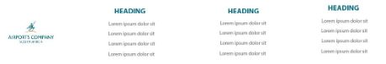

Figure 15 Footer and Logo Links

The footer logo and links are found inside the page footer. The logo will act as a link to the root of the ACSA Intranet site.

Next to the logo 3 (three) header links will be displayed. ACSA will provide eSoftware Solutions with the link titles, and the link URLs before the build cycle of the project is complete. These links can only be modified by editing the Home Page Master Page and/or Sub Home Master page with SharePoint 2013 Designer.

## Page Layouts

A Page Layout can be thought of as a template structure for SharePoint pages. Page Layouts depict what elements are displayed on the page and where those elements may be placed. When combined with a master page, a page layout defines the layout and branding of a SharePoint page. Web Parts are placed in Web Part Zones. Web Part Zones make it easy for a user with contributor rights to move Web Parts around. Each Web Part Zone could be styled differently, enabling a web part to appear differently, depending on which Web Part Zone it is placed in.

When a page is created, it must be associated with a single page layout (which can be changed at a later stage if required). The page contains the actual data or content in the page.

The following 2 (two) page layouts will be created for the ACSA Intranet:

### 3.3.1 Layout with Top Navigation



Figure 16 Layout with Top Navigation

### 3.3.2 Layout without Left Navigation

The image below illustrates a layout without left navigation.



Figure 17 Layout with Left Navigation

# SITE TAXONOMY

A site taxonomy is the physical site structure created within SharePoint by adding sub sites and pages. The site taxonomy should not be confused with the items seen in the Mega Menu (see section 10.2.1).

In the absence of a formal site taxonomy, the table below was compiled to consolidate information collected from the various divisional Business Requirements Documents. The table illustrates content that has been supplied and content that is outstanding per division/department.

|  |  |  |  |  |  |
| --- | --- | --- | --- | --- | --- |
| **Division** | **Department** | **Tab** | **Content Provided** | **Content Type** | **Management of Content** |
| **Supply Chain Management**  **Divisional Overview (including Division Strategy; Mission and Vision)** The below diagram is an illustration of Supply Chain Management’s Vision 2025:    The below diagram depicts the new Supply Chain Management’s governance documents as well as the BAC structure:  **Divisional Organogram**  The below diagram depicts the Supply Chain Management’s division organogram: | **Category Management**  **Purpose**  Lead demand planning for all sourcing categories to develop the relevant category strategies and execute all strategic sourcing activities  **Services Provided** Below is a list of services provided by the Category Management department: 1. Develop and ensure timely execution category strategy and savings target achievement. 2. Lead demand planning for specific category to enable the compiling of relevant/related procurement strategies for the sourcing of materials and services. 3. Lead all aspects related to the establishment and management of a portfolio of contracts in the category, (which are commercially beneficial with regards to cost, quality and delivery for the internal customers) including sourcing, contract negotiations, supplier performance, review and lifecycle management 4. Evaluate supplier data and develop marketplace insights for the various commodities within the category  **Organogram**  The below diagram depicts the Category Management department’s organogram: | Events and Other Information | No content provided | N/A | N/A |
| Documents; Templates  and Policies | <http://jnbproderweb/sites/PMDS/SitePages/Intro.aspx> | Hyperlink | Digital Content Specialist |
| Contacts | No content provided | N/A | N/A |
| KPIs | No content provided | N/A | N/A |
| **Business Services Purpose**  Lead all transactional sourcing activities across the business, continuously driving improvements in efficiency and service delivery.  **Services Provided by Business Services**  Below is a list of the services provided by the Business Services department: • Lead the provision of business supply chain management services at both Airports and Corporate office and continuously drive improvements in efficiency and service delivery • Ensure effective demand planning and consolidation as an input to category management. • Lead the end-to-end RFX process for materials/services while ensuring adherence and execution against supplier contracts • Oversee the levels & movements of inventory over the ACSA network and manage asset disposal and commercial tendering processes  **Organogram** The below diagram depicts the Business Services department’s organogram: | Events and Other Information | No content provided | N/A | N/A |
| Documents; Templates  and Policies | <http://jnbproderweb/sites/PMDS/SitePages/Intro.aspx> | Hyperlink | Digital Content Specialist |
| Contacts | No content provided | N/A | N/A |
| KPIs | No content provided | N/A | N/A |
| **Performance Monitoring & Governance  Purpose**  Responsible for the management of risks, compliance adherence, governance and performance related to SCM across ACSA.  **Services Provided by Performance Monitoring and Governance**  Below is a list of the services provided by the Performance Monitoring and Governance department: • Monitor performance of SCM activities and evaluate against ACSA specific KPIs • Maintain overall SCM policy to include all updates in order to have a complete and simple SCM policy document • Handle legal or compliance queries related to SCM to improve compliance without stalling seamless sourcing • Promote seamless contracts management process enabling coordination and facilitation of the contracting process from drafting to execution  **Organogram**  The below diagram depicts the Performance Monitoring and Governance department’s organogram: | Events and Other Information | No content provided | N/A | N/A |
| Documents; Templates  and Policies | <http://jnbproderweb/sites/PMDS/SitePages/Intro.aspx> | Hyperlink | Digital Content Specialist |
| Contacts | No content provided | N/A | N/A |
| KPIs | No content provided | N/A | N/A |
| **Systems & Data Integration  Purpose**  Support efforts to drive continuous improvement and accuracy in SCM transactions and drive systems efficiencies using SCM information system knowledge and best practice  **Services Provided by Systems and Data Integration**  Below is a list of the services provided by the Systems and Data Integration department: • Management of IT projects for SCM, through the review and investigation of data quality between systems, processes and people • Focus on master data and SCM IT solutions strategic planning • Enhancement of IT infrastructure and SCM modules and technical solutions to enable increased process efficiency, reporting and enhanced analytical capabilities • Development of Data Management Strategies to support SCM as an enabling function  **Organogram**  The below diagram depicts the Systems and Data Integration department’s organogram: | Events and Other Information | No content provided | N/A | N/A |
| Documents; Templates  and Policies | <http://jnbproderweb/sites/PMDS/SitePages/Intro.aspx> | Hyperlink | Digital Content Specialist |
| Contacts | No content provided | N/A | N/A |
| KPIs | No content provided | N/A | N/A |
| **Airport Management**  **Divisional Overview (including Division Strategy; Mission and Vision)** This is the description of the division, explaining at a high level what the division is responsible for.  Airports Management operates all ACSA airports in an efficient, safe, secure and sustainable manner, whilst ensuring that all airlines’ and passengers’ expectations are met.  **Divisional Organogram**  The below diagram depicts the Airports Management division organogram: | **Network Strategy & Performance**  **Purpose**  To enable an effective and integrated network of airports through planning, performance management & continuous business improvement.  **Services Provided by Network Strategy & Performance**  Below is a list of the services provided by the Network Strategy & Performance department: • Network Strategy • Implementation plan prioritisation and alignment towards capacity constraints • Process mapping guidelines • Performance Management guidelines • AM Planning guidelines • Business Improvement guidelines • Seasonal Capacity and Demand Plans and Medium-Term Simulations • Performance Management Platform (BI) • Business Improvement Initiatives   **Organogram**  The below diagram depicts the Network Strategy & Performance department organogram: | Events and Other Information | No content provided | N/A | N/A |
| Documents; Templates  and Policies | <http://jnbproderweb/sites/PMDS/SitePages/Intro.aspx> | Hyperlink | Digital Content Specialist |
| Contacts | No content provided | N/A | N/A |
| KPIs | No content provided | N/A | N/A |
| Useful Links | **AMS:**   * + - [AMS USER ACCESS FORM](http://10.40.43.39/files/AMS001%20-%20AMS%20USER%20ACCESS%20FORM%20REV%200.9.pdf)     - [AMS UAT TESTING FEB 2016](https://app.smartsheet.com/b/home?lx=tU-z-uVt3bgmBhRtb-SzLw)     - [AMS TRAINING DOCUMENTATION](http://10.40.43.39/files/AMS%20Upgrade%20Project%20-%20System%20&%20Process%20Training%20R4.01.pdf)   **BLUEWORKSLIVE:**   * + - [BLUEWORKSLIVE URL](http://www.blueworkslive.com/)   **QLIKVIEW:**   * + - [QLIKVIEW URL](http://196.11.3.89/QLIKVIEW)   **Surveys:**   * + - [JNB AMC STAKEHOLDER SURVEY](https://app.smartsheet.com/b/form?EQBCT=23e6b46ba1ec4a3facd578dbf7e8c18b) (not available)     - [AMS USER SURVEY](https://app.smartsheet.com/b/form?EQBCT=b680629f7f9140e8a574cd4595a245e9)   **IT:**   * + - [SYSTEM ACCESS FOR ZEUS/AMS/QV/BW](https://app.smartsheet.com/b/form?EQBCT=bc17249e352c45b7a01cdde968ba7b32)   **System Administrators:**   * + - [SYSTEM USER DATABASE](https://app.smartsheet.com/b/form?EQBCT=129ccda938a34f6691e86671999429af)   **APEX:**   * + - [APEX USER ACCESS FORM](http://10.40.43.39/files/APEX%20USER%20ACCESS%20FORM%20VERSION%201.0.pdf) (is this linked to a procedure…not e-form)     - [APEX TRAINING MANUAL](http://10.40.43.79/files/APEX%20Training.pdf)     - [LOG APEX ISSUES](https://app.smartsheet.com/b/form?EQBCT=7f4b98383b8a4c689ae7be80acce4570)     - [CARRIER TO HANDLER REQUEST](https://app.smartsheet.com/b/form?EQBCT=5a488e3c216546858cf2b964af3828ab)     - [APEX STANDS UPLOAD TEMPLATE](http://10.40.43.39/files/STANDS.XLSX) - (UPLOAD DESTINATION)     - [APEX AIRBRIDGES UPLOAD TEMPLATE](http://10.40.43.39/files/AIRBRIDGES.XLSX) – (UPLOAD DESTINATION)     - [APEX TAXIWAYS UPLOAD TEMPLATE](http://10.40.43.39/files/TAXIWAYS.XLSX) – (UPLOAD DESTINATION)     - [APEX RUNWAYS UPLOAD TEMPLATE](http://10.40.43.39/files/RUNWAYS.XLSX) – (UPLOAD DESTINATION)     - [APEX FUELLING UPLOAD TEMPLATE](http://10.40.43.39/files/FUELLING.XLSX) – (UPLOAD DESTINATION)   **Capacity Information:**   * + - [ORTIA 81 STAND DECLARATION](http://10.40.43.39/files/ORTIA%20BAY%20COUNT%20ANALYSIS.pdf)   **Planning:**   * + - [24 HOUR RESOURCE ALLOCATION CHECKLIST](https://app.smartsheet.com/b/form?EQBCT=53364e822e3641acaa88006aae6d60a8)   **Slot Issues:**   * [LOG ALL SLOT RELATED ISSUES](https://app.smartsheet.com/b/form?EQBCT=1e11975c39e44c8ea38f136bd741f2da) * [MANUAL ON FLOW MANAGEMENT](http://10.40.43.39/files/Manual%20on%20Collaborative%20Flow%20Management.pdf)   **Processes:**   * [PROCESS MAPPING TOOLKIT](http://10.40.43.79/files/Airport%20Management%20Process%20Mapping%20Toolkit%20Master.pdf)   **Airside Capacity Study:**   * + - [TASK1 KICKOFF](http://10.40.43.39/files/Task1%20Kickoff.pdf)     - [TASK2 TECHINCAL ANALYSIS](http://10.40.43.39/files/Task2%20Techincal%20Analysis.pdf)     - [TASK3 ECONOMIC & FINANCIAL ANALYSIS](http://10.40.43.39/files/Task3%20Economic%20and%20Financial%20Analysis.pdf)     - [TASK4 LEGAL & REGULATORY](http://10.40.43.39/files/Task4%20Legal%20and%20Regulatory.pdf)     - [TASK5 ENVIRONMENTAL IDENTFICATION](http://10.40.43.39/files/Task5%20Environmental%20Identification.pdf)     - [TASK6 SPECIFICATIONS & RECOMMENDATIONS](http://10.40.43.39/files/Task6%20Specifications%20and%20Recommendations.pdf)     - [TASK7 DEVELOPMENT PLAN](http://10.40.43.39/files/Task7%20Development%20Impact.pdf)     - [TASK8 IMPLEMENTATION PLAN](http://10.40.43.39/files/Task8%20Implementation%20Plan.pdf)     - [TASK9 FINAL REPORT](http://10.40.43.39/files/Task9%20Final%20Report.pdf) | Hyperlink | Digital Content Specialist |
| **Regulatory & Quality Assurance**  **Purpose**  Ensure compliance with regulations and influence the regulator in the areas of Aviation Safety, Airport Rescue & Fire Fighting (ARFF) and Environment.  **Services Provided by Regulatory & Quality Assurance**  To provide frameworks, policies, procedures and standards for Aviation Safety, ARFF, Environment,  Fleet Management, Technical Standards and Quality Management to ensure regulatory compliance  **Organogram**  The below diagram depicts the Regulatory & Quality Assurance department organogram: | Events and Other Information | No content provided | N/A | N/A |
| Documents; Templates  and Policies | <http://jnbproderweb/sites/PMDS/SitePages/Intro.aspx> | Hyperlink | Digital Content Specialist |
| Contacts | No content provided | N/A | N/A |
| KPIs | No content provided | N/A | N/A |
| **Client Services**  **Purpose**  To enable users of airports and provide and enhanced and responsive customer experience.  **Services Provided by Client Services**  Below is a list of the services provided by the Client Services department:  • KAM Framework (across the business)  • Drive ASQ Performance (QMS, SFS, SS)  • Behavioural training framework for airport community (with a focus on Security and Immigration)  • Passenger experience improvement initiatives  • Prioritisation of initiatives  • Alignment of processes and procedures (across all business divisions)  • Event management framework  • Digitisation  **Organogram**  The below diagram depicts the Client Services department organogram: | Events and Other Information | No content provided | N/A | N/A |
| Documents; Templates  and Policies | <http://jnbproderweb/sites/PMDS/SitePages/Intro.aspx> | Hyperlink | Digital Content Specialist |
| Contacts | No content provided | N/A | N/A |
| KPIs | No content provided | N/A | N/A |
| **Enterprise Security** Divisional Overview (including Division Strategy; Mission and Vision) This is the description of the division, explaining at a high level what the division is responsible for.  The main objective of Security is to provide strategic and operational direction on security standards and practices at enterprise and airports level, with the aim of ensuring leadership and coordination of Airports Company South Africa Security activities and to develop and deliver an integrated approach to security and service quality of airport security operations. Delivering a risk based security service for the protection of assets, personnel and information is a key function.  **What does Enterprise Security mean to ACSA**  Developing and implementing comprehensive and integrated security solutions throughout the organisation will give ACSA a competitive advantage and ensure passenger and stakeholder satisfaction.  Aviation is the ‘business of freedom’, a catalyst for social and economic development that improves people’s lives. That’s why partnerships are essential to address our major security challenges with the speed needed to stay a step ahead of those who would do our industry harm. These efforts must keep four common principles in focus: risk-based measures, the implementation of global standards, capacity building to support the mutual recognition of standards, and information sharing among governments and with industry.  Enterprise Security has the below pillars to drive the embedding of an effective and efficient enterprise security management principles, processes and structures across ACSA and all airport stakeholders:    **What can employees contribute to Enterprise Security**   * A security culture is born out of joint working, looking at security from a holistic approach, how we can pool our resources, involving and including the airport community, investing in the human factor combined with technology. * Collaboration, integration and communication will enhance the ability of the airport to protect, prevent, prepare and react in a time of crisis can only be achieved by working together. * Employees should be mindful of the environment and how vulnerable it is * Understanding Security threats and how it manifests itself within the environment. * Report security breaches and security threats, seeking clarity where there are uncertainties  Divisional Organogram The below diagram depicts the Enterprise Security division organogram: | Enterprise SecurityPurpose To lead and secure the integrity of business by promoting a security consciousness within the organisation. Services Provided by Enterprise Security Below is a list of the services provided by the Enterprise Security department:   * Development of security framework including policies and procedures for protection of ACSA assets, information and employees * Providing a secure working environment with regards to physical, information, cyber security and vetting of employees * Airport services:   Implementing security policies and procedures for protection of ACSA assets, information and employees (vetting, physical, information and cyber security)  The below diagram depicts the Enterprise Security department organogram: | Events and Other Information | No content provided | N/A | N/A |
| Documents; Templates  and Policies | <http://jnbproderweb/sites/PMDS/SitePages/Intro.aspx> | Hyperlink | Digital Content Specialist |
| Contacts | No content provided | N/A | N/A |
| KPIs | No content provided | N/A | N/A |
| **SECURITY RISK MANAGEMENT** Purpose The purpose of the security risk management process is to manage and effectively control risk appropriately within the company’s overall risk appetite. To manage security risk exposures with the objective of preventing a loss event from occurring or minimising the effect should such an event occur.  Risk management principles acknowledge that while risk generally cannot be eliminated, enhancing security measures linked to known or potential threats by identifying strategic opportunities can reduce uncertainty. Services Provided by Security Risk Management Below is a list of the services provided by the Security Risk Management department:   * Ensure that frameworks and methodologies are implemented to increase the probability of anticipating unpredictable risk. * The establishment of an integrated security risk management strategy * Ensuring that monitoring of processes and outcomes of key risk indicators are undertaken * Monitoring compliance with applicable legislation * Ensure that risk assessments are performed on a continuous basis  Organogram The below diagram depicts the Security Risk Management department organogram: | Events and Other Information | No content provided | N/A | N/A |
| Documents; Templates  and Policies | <http://jnbproderweb/sites/PMDS/SitePages/Intro.aspx> | Hyperlink | Digital Content Specialist |
| Contacts | No content provided | N/A | N/A |
| KPIs | No content provided | N/A | N/A |
| **AIRPORT SECURITY** Purpose To develop and implement airport security plan to prevent unlawful interference with airport operations and facilitate the security and safety of all airport users. Services Provided by Airport Security Below is a list of the services provided by the Airport Security department:   * Develop and implement Airport Security Strategic Plan * Develop and implement ASP * Provide security advice to airport management * Implementation of the Security Master Plan * Effective management of security contracts * Safe Passenger Experience * Facilitation of baggage and cargo * Oversight of General Aviation * Develop and implement a public safety / security plan * Ensure all public areas and vulnerable installations are safe and secure  Organogram The below diagram depicts the Airport Security department organogram: | Events and Other Information | No content provided | N/A | N/A |
| Documents; Templates  and Policies | <http://jnbproderweb/sites/PMDS/SitePages/Intro.aspx> | Hyperlink | Digital Content Specialist |
| Contacts | No content provided | N/A | N/A |
| KPIs | No content provided | N/A | N/A |
| **Business Development** Divisional Overview (including Division Strategy; Mission and Vision) In 2014, Airports Company South Africa (ACSA) embarked on a business restructuring process that resulted in new strategic focus areas being defined. One of the outcomes of this process was the formation of a Business Development (BD) Department which was given the mandate previously assigned to the Airport Management Solutions (AMS) department, amongst others. BD has the responsibility of monetising ACSA intellectual property by growing the footprint through provision of training, consultancy, management services and investments in airport concessions. It is also responsible for development of passengers and cargo traffic across all ACSA managed airports to enhance connectivity and grow the number of departing seats. Objectives of BD The strategic objectives of the BD Division support the KPI Framework from the ACSA Strategy 2025. Particular emphasis is placed on meeting the following objectives:   * **Create value for our shareholders**; by carrying out net positive return consultancy, training services, and participating in investments with high return on equity. * **Contribute to increased traffic through the airports we operate**; by pro-actively developing passenger and cargo traffic at the network of ACSA airports, as well as other airports in South Africa. * **Diversify our business portfolio**; by increasing income from non-core activities, such as consulting, training services and investments, and increasing the share of non-aeronautical revenues. * **Provide equitable access to safe airports in all SA regions to allow more people to fly**; by supporting non-ACSA airports in South Africa. * **Improve connectivity to the regions we serve**; by increasing air traffic at all the airports in the ACSA network.   Business Development Strategy Document | Market Research and Analysis **Purpose**  Assess the business environment for BD related activities to determine their respective viability, and to also provide an analysis of the business environment for the traditional operations of ACSA to enable appropriate proactive management in pursue of enhancing shareholder value. Evaluate and influence applicable regulation and bilateral agreements to enable air service development and connectivity enhancements. Services Provided by Market Research and Analysis Below is a list of the services provided by the Market Research and Analysis department:   * Provision of fundamentally backed traffic forecast to form a basis of both long-term infrastructure planning short term operational planning. * Passenger profiling for the purpose of enhanced commercial performance * Assessment of the viability of opportunities being pursued by ODI * Provide fundamentals backing traffic development initiatives to determine the sustainability of a route being pursued  Organogram The below diagram depicts the Market Research and Analysis department’s organogram with the Group Manager as well as the direct reports | Events and Other Information | No content provided | N/A | N/A |
| Documents; Templates  and Policies | <http://jnbproderweb/sites/PMDS/SitePages/Intro.aspx> | Hyperlink | Digital Content Specialist |
| Contacts | No content provided | N/A | N/A |
| KPIs | No content provided | N/A | N/A |
| MARKETINGPurpose Implement and monitor marketing strategies and plans to support Commercial and Business Development opportunities. Services Provided by Marketing Below is a list of the services provided by the Marketing department:   * To support and work closely with commercial department customers (i.e. tenants and concessionaires) * Supporting the commercial department through marketing activities (i.e. awareness campaigns, promotions, customer experience) * Increase commercial revenues * Assisting airports with customer experience and ambiance * Positioning the airports as world class * To position ACSA as an airports management partner of choice * To promote and commercialise ACSA’s intellectual property i.e. training academy; engineering etc  Organogram The below diagram depicts the Marketing department’s organogram with the Group Manager as well as the direct reports: | Events and Other Information | No content provided | N/A | N/A |
| Documents; Templates  and Policies | <http://jnbproderweb/sites/PMDS/SitePages/Intro.aspx> | Hyperlink | Digital Content Specialist |
| Contacts | No content provided | N/A | N/A |
| KPIs | No content provided | N/A | N/A |
| Traffic DevelopmentPurpose To enhance air connectivity with global gateways, which enables seamless flow of trade and tourism with our region Southern Africa. Services Provided by Traffic Development Below is a list of the services provided by the Traffic Development department:   * Provide market analysis and route opportunity recommendations to potential/ current airlines * Engage directly with airlines, Tourism Agencies, Local governments, economic development, NDOT (on Bilateral Affairs) on matters relating to traffic development with the aim to enhance air connectivity * Coordination and handover of operators to KAM/ customer service once committed to operate * Initiate and support key local governments initiatives such as route development project, aerotropolis, aviation competitive analysis and any other initiative relevant to traffic development  Organogram The below diagram depicts the Traffic Development department’s organogram with the Group Manager as well as the direct reports: | Events and Other Information | No content provided | N/A | N/A |
| Documents; Templates  and Policies | <http://jnbproderweb/sites/PMDS/SitePages/Intro.aspx> | Hyperlink | Digital Content Specialist |
| Contacts | No content provided | N/A | N/A |
| KPIs | No content provided | N/A | N/A |
| Opportunity Development & InvestmentPurpose Develop and manage the delivery of investment, airport services and related opportunities. Services Provided by Opportunity Development & Investment Below is a list of the services provided by the Opportunity Development & Investment department:   * Develop and manage list of potential investment/ technical partners * Select and negotiate with potential investment/ technical partners of interest * Enter into collaboration agreements with potential partners * Scan and analyse market for airport services and concession opportunities in line with the BD’s investment mandate * Select opportunities and negotiate project and finance agreement * Establish the joint venture or subsidiary  Organogram The below diagram depicts the Opportunity Development & Investment department’s organogram with the Group Manager as well as the direct reports: | Events and Other Information | No content provided | N/A | N/A |
| Documents; Templates  and Policies | <http://jnbproderweb/sites/PMDS/SitePages/Intro.aspx> | Hyperlink | Digital Content Specialist |
| Contacts | No content provided | N/A | N/A |
| KPIs | No content provided | N/A | N/A |
| Corporate AffairsDivisional Overview (including Division Strategy; Mission and Vision) Below is the Corporate Affairs group strategy:   Corporate Affairs Purpose To **position** and **promote** Airports Company South Africa as a **reputable** world class partner of choice in an innovative and suitable manner for the benefit of **stakeholders** Divisional KPIs Below are the Corporate Affairs Key Performance Indicator   * Improve reputation * Assess stakeholder relations * Employee satisfaction survey * Leadership index  Divisional Organogram The below diagram depicts Corporate Affairs division organogram: | Corporate Affairs Brand ManagementObjectives Below are the objectives of Corporate Affairs and Brand Management   * Assess perceived awareness of the brand * Position the brand * Live the brand  Organogram The below diagram depicts the Corporate Affairs Brand Management department organogram: | Events and Other Information | No content provided | N/A | N/A |
| Documents; Templates  and Policies | <http://jnbproderweb/sites/PMDS/SitePages/Intro.aspx> | Hyperlink | Digital Content Specialist |
| Contacts | No content provided | N/A | N/A |
| KPIs | Key Performance Indicator Below are Corporate Affairs and Brand Management KPIs   * Qualitative (Findings) and Quantitative (Brand Value) Analysis * Develop strategy and implementation plan * Coordinate and activate brand and marketing platforms | Text | Digital Content Specialist |
| Stakeholder RelationsObjectives Below are the objectives of Stakeholder Relations   * Build growing and improving relationships * Build trust with stakeholders * Formalise partnerships for business growth and sustainability  Organogram The below diagram depicts the Stakeholder Relations department organogram: | Events and Other Information | No content provided | N/A | N/A |
| Documents; Templates  and Policies | <http://jnbproderweb/sites/PMDS/SitePages/Intro.aspx> | Hyperlink | Digital Content Specialist |
| Contacts | No content provided | N/A | N/A |
| KPIs | Key Performance Indicator Below are Stakeholder Relations KPIs   * Monitor and track the delivery of the approved stakeholder engagement plan * Assess and report on the stakeholder relationship engagements through stakeholder owners (pulse check) * Facilitate formal partnership agreements, SLA’s and MOU’s with key stakeholders | Text | Digital Content Specialist |
| Socio-Economic DevelopmentObjectives Below are the objectives of the Socio-Economic Development department   * Deliver impactful education interventions * Create economic opportunities for women, youth and persons with disabilities * Contribute to environmental sustainability  Organogram The below diagram depicts the Socio-Economic Development department organogram: | Events and Other Information | No content provided | N/A | N/A |
| Documents; Templates  and Policies | <http://jnbproderweb/sites/PMDS/SitePages/Intro.aspx> | Hyperlink | Digital Content Specialist |
| Contacts | No content provided | N/A | N/A |
| KPIs | Key Performance Indicator Below are Socio-Economic Development KPIs   * Invest in education opportunities to bona fide beneficiaries (Black South Africans as defined by B-BBEE Act) thereby enabling direct and indirect sustainable livelihoods * Invest in economic opportunities to bona fide beneficiaries (Black South Africans as defined by B-BBEE Act) to enable direct and indirect sustainable livelihoods * Invest in environmental prospects to conserve, protect and preserve the environment for future generations | N/A | N/A |
| Corporate Affairs Internal CommunicationsObjectives Below are the objectives of the Corporate Affairs Internal Communications department   * Drive interactive engagement * Deliver relevant, accurate and timely information * Entrench ACSA PRIDE values and strategy  Organogram The below diagram depicts the Corporate Affairs Internal Communications organogram: | Events and Other Information | No content provided | N/A | N/A |
| Documents; Templates  and Policies | <http://jnbproderweb/sites/PMDS/SitePages/Intro.aspx> | Hyperlink | Digital Content Specialist |
| Contacts | No content provided | N/A | N/A |
| KPIs | Key Performance Indicator Below are Socio-Economic Development KPIs   * Lead and coordinate all planned internal communication activities * Provide strategic communication support to our business * Employee engagements on Company strategy and PRIDE values | Text | Digital Content Specialist |
| **Transformation** Divisional Overview (including Division Strategy; Mission and Vision) **Transformation in Action**  Airports Company South Africa is committed to developing the socio-economic status of the previously disadvantaged South Africans. Our transformation initiatives look beyond legislation and focus on tangible development to strengthen our democracy.  We are committed to the transformation imperatives of the National Development Plan to seek to aid the eradication of poverty through various programmes and initiatives. Socially, we position ourselves in a manner that guides development while embodying equality and fairness.  The Company’s and country’s needs inform our transformation model and activities, which directly relate to our strategy.  **Transformation Imperatives**  Align with government’s focus areas.  Social Imperative  Design and implement socio-economic activities that will empower our communities to ultimately lead better lives  Moral Imperative  Create fair, transparent, equal opportunities for the economically active population and eliminate unfair discrimination  Economic Imperative  Develop small, medium and large sized businesses with a broad objective of changing the face of business at Airports Company South Africa to reflect South African demographics.  **Sustainability Framework**  The framework guides the decisions and actions of our strategy  Our Business  Increase our reputation, improve passenger experience, increase stakeholder satisfaction, increase airport traffic and diversify our business.  Our People and Society  Contribute more to black economic empowerment, support black business growth, provide improved access to airports, improve the connectivity to region we serve, diversify our workforce and create a positive environment for our employees.  Our Environment  Minimize our environmental impact and strive to be carbon neutral | N/A | N/A | N/A | N/A | N/A |
| N/A | N/A | N/A | N/A |
| N/A | N/A | N/A | N/A |
| N/A | N/A | N/A | N/A |
| **Corporate Strategy and Performance** Divisional Overview (including Division Strategy; Mission and Vision)Purpose To create value aligned to Airports Company South Africa’s mission and vision by facilitating strategy formulation and execution, translating agreed strategies into business plans with the respective divisions, and supporting organisational performance Services provided Strategy Development  Facilitate development of the Airports Company South Africa corporate strategy, translate strategy into divisional plans, monitor and report on strategic initiatives, drive mitigation solutions where required and prepare the quarterly and annual integrated report.  Business Planning and Performance Management  Provide development support to Executives of respective divisional business plans, consolidate divisional performance reports, analyse business performance and progress on strategic initiatives. Divisional Organogram The below diagram depicts the Corporate Strategy and Performance division’s organogram: | N/A | N/A | N/A | N/A | N/A |
| N/A | N/A | N/A | N/A |
| N/A | N/A | N/A | N/A |
| N/A | N/A | N/A | N/A |
| **Infrastructure Asset Management** Divisional Overview (including Division Strategy; Mission and Vision) This is the description of the division, explaining at a high level what the division is responsible for.  To plan, commercialize, develop and manage ACSA’s asset portfolio to align to business strategy and priorities, and drive sustainable results. Coordinate the Infrastructure Asset Management (IAM) area functions and ensure adequate and consistent infrastructure development.  Below are the functions of Infrastructure Asset Management:   * Conduct integrated planning inclusive of Airport Master Plans, Precinct and Services Coordination Plans, through to Development and Building Plans * Drive commercial viability for aeronautical and non-aeronautical assets * Manage, monitor, analyse and optimise the performance of the Real Estate portfolio * Plan, coordinate and manage the development of ACSA’s infrastructure inclusive of partner deal structuring. * Determine Asset Management requirements and strategies, and drive return on infrastructure assets across asset lifecycles * To develop regionally relevant and sustainable airport infrastructure solutions * Provide enabling frameworks that are stakeholder-oriented and sustainable (i.e. socially responsible, environmentally responsible and economically and socially transformative) * Importantly, viable to proactively respond to demand * Support and promote the respective regional aspirations    Divisional Organogram The below diagram depicts the Infrastructure Asset Management division organogram: | Real EstatePurpose To review portfolio and assess opportunities; Manage leases; Manage and analyse Real Estate performance.  Below are the processes performed under Real Estate department:   Services Provided by Real Estate Below is a list of the services provided by the Real Estate:   Organogram The below diagram depicts the Real Estate department organogram:   Spatial Portfolio Airports Company South Africa SOC Limited, as a world-class airport operator provides prime real estate to tenants who lease out commercial space in terminal buildings, diverse properties such to include but not limited to hotels, petrol stations, fuel farms and industrial properties which include but are not limited to warehouses, cargo facilities and land.  The Spatial team are responsible and accountable for the letting of real estate space, growing the letting portfolio, servicing the internal and external stakeholders that lease the space as well as those that are impacted by the leasing, and compliance to the laws of the land and Company Policy Documents in concluding transactions with the lessees.  To this end, the Spatial Portfolio team are committed to the following below ensuring that Airports Company South Africa SOC Limited are able to achieve the above: -   1. Continually review spatial portfolio and Assess Opportunities; 2. Conduct Marketing initiatives to market spatial portfolio; 3. Assess economic and contracting models for spatial portfolio; 4. Manage leases and tenders; and 5. Manage and analyse commercial performance.  Infrastructure Property Development **Purpose**  Formulation and implementation of ACSA’s Infrastructure and Property Development 5-10 year strategy across the network of airports. To lead, manage and implement the Infrastructure and Property portfolio and significantly increase ACSA’s non-aeronautical revenues and value, including the implementation of transformation imperatives through the development value chain with consideration to the regulatory frameworks, broader business and country economic factors.  **Services**   1. Land conversion and enablement 2. Growing real estate revenue through the development of 1000Ha of serviceable land 3. Commercial asset optimization/ re-development 4. Deal management and structuring 5. Strategic Land acquisition | Events and Other Information | No content provided | N/A | N/A |
| Documents; Templates  and Policies | <http://jnbproderweb/sites/PMDS/SitePages/Intro.aspx> | Hyperlink | Digital Content Specialist |
| Contacts | No content provided | N/A | N/A |
| KPIs | No content provided | N/A | N/A |
| Economic Modelling ServicesPurpose To develop business and economic modelling tools and scenario sets to support Integrated Planning, Permission Applications, Commercial Contracting and Deal Structuring. Services Provided by Economic Modelling Services Below is a list of the services provided by the Economic Modelling Services department:   * The validation of the envisaged value of commercial appeal and worth of the portfolio(s) * The use of recognised economic and business modelling techniques used to estimate the probabilities of success and viability of different scenarios * Identification of ACSA’s suitability to adopt proposed solutions and modelling their corresponding Return on Investment * Socio-economic impacts of the CAPEX programmes across operations and the respective regions (within which ACSA operates) * Project escalation models  Organogram The below diagram depicts the Economic Modelling Services department organogram: | Events and Other Information | No content provided | N/A | N/A |
| Documents; Templates  and Policies | <http://jnbproderweb/sites/PMDS/SitePages/Intro.aspx> | Hyperlink | Digital Content Specialist |
| Contacts | No content provided | N/A | N/A |
| KPIs | No content provided | N/A | N/A |
| Integrated PlanningPurpose To provide sustainable and regionally relevant airport infrastructure solutions. Services Provided by Integrated Planning Below is a list of the services provided by the Integrated Planning department:   * Airport Development Frameworks/Plans (Master, Precinct and Development Plans) * Capacity and Demand Analysis of Airport Subsystems (Airside, Terminal, Landside) * Conceptual Landside, Terminal and Airside Design * Regional Integration of Airport Planning and Development * External Development Plan Application Evaluations  Organogram The below diagram depicts the Integrated Planning department organogram: | Events and Other Information | No content provided | N/A | N/A |
| Documents; Templates  and Policies | <http://jnbproderweb/sites/PMDS/SitePages/Intro.aspx> | Hyperlink | Digital Content Specialist |
| Contacts | No content provided | N/A | N/A |
| KPIs | No content provided | N/A | N/A |
| Enterprise Asset ManagementPurpose Manage ACSA’s infrastructure and assets across the entire lifecycle, while optimising the return on asset levels through safe and relevant engineering practises and technology selection that is suitable for an airport environment. Services Provided by Enterprise Asset Management Below is a list of the services provided by the different business areas under the Enterprise Asset Management department:   * Manage and oversee the effective utilisation of assets through implementation of practices and processes to drive standardisation across airport as necessary while optimising return on asset levels and transferring know how to new developments/ventures. * Develop/Adopt and drive best, innovative and sustainable engineering practices for airport specific infrastructure within sound engineering frameworks and standards. Build high quality Engineering capabilities throughout the Group. * Create a safe and healthy environment for the airport community (employees, stakeholders, contractors, tenants) and ensure compliance with all applicable statutory legal and other requirements * Create, capture and transfer the body of knowledge of technologies and engineering applications across the Group.  Organogram The below diagram depicts the Enterprise Asset Management department organogram: | Events and Other Information | No content provided | N/A | N/A |
| Documents; Templates  and Policies | <http://jnbproderweb/sites/PMDS/SitePages/Intro.aspx> | Hyperlink | Digital Content Specialist |
| Contacts | No content provided | N/A | N/A |
| KPIs | No content provided | N/A | N/A |
| **Technical Services & Solutions**  **Divisional Overview (including Division Strategy; Mission and Vision)**  To provide technical insight and convert customer needs into sustainable airport management solutions.       Divisional Organogram This is the depiction of the structure of the division | Technical Research and DevelopmentPurpose Provide technical insight and convert customer needs into sustainable airport management solutions.     High-level Process facilitated by Technical Research and Development Below is a list of the services provided by the Technical Research and Development:   Organogram The below diagram depicts the Technical Research and Development department organogram: | Events and Other Information | No content provided | N/A | N/A |
| Documents; Templates  and Policies | <http://jnbproderweb/sites/PMDS/SitePages/Intro.aspx> | Hyperlink | Digital Content Specialist |
| Contacts | No content provided | N/A | N/A |
| KPIs | No content provided | N/A | N/A |
| Advisory ServicesPurpose To provide technical advisory services and integrated solutions to airports both locally and abroad. Services Provided by Advisory Services The services offered by Advisory can be classified as follows:    Airport Business Planning and Development   * The areas of airport business planning and development includes the portfolios of airport planning, stakeholder relations, project management as well as airport due diligence assessments. A panel of experts is assembled within each area to: * Align and integrate airport development with the broader regional plans to ensure the effective use of airport resources; * Provide strategic framework to guide stakeholder relations with partners; * Ensure the efficient and agile delivery of airport infrastructure projects and * Conducting technical assessments of airports to provide clients with optimal solutions to effectively and efficiently run and grow their airports.   Airport Operations, Management and Regulation   * Airport Operations, Management and Regulation Advisory teams focus on the areas of airport management, operations and operational readiness and airport transfer of new airports or terminals. A special panel of experts from the airport management space are assembled to: * Ensure airports maintain a certain regulatory standard in the areas of airport safety, security, airfield rescue and firefighting; * Ensure collaborative decision-making and effective business process planning to improve passenger experience, travel efficiency, services quality and allowing seamless connectivity to passengers. * Tailor make operational readiness and airport transfer programs for the needs of each client to ensure the smooth and safe transfer of a new airport or terminal.   Commercial Advisory   * Commercial Advisory focuses on the optimisation of airport revenues and ensures airports capitalise on non-aeronautical revenue such as concessions for retail, food and beverage, car rental, car parking, property development and advertising.  Achievements Kotoka International Airport, Accra, Ghana  Airports Company South Africa is proud of the partnership with Ghana Airports Company Limited (GACL), and to be part of unlocking Ghana as the preferred hub in West Africa. Kotoka Airport represents the international gateway to Ghana. The successful commissioning of Terminal 3 will not only assist with meeting the current and future needs of GACL but also attract business opportunities and create employment.  The opening of the new terminal will be a time of national pride and celebration (scheduled for August). Airports Company South Africa has a shared responsibility to ensure that the GACL teams have the skills to implement change, and to guarantee a seamless transition of all processes into the new terminal building. This entails not only assisting GACL with Terminal 3’s Operational Readiness and Airport Transfer (ORAT) challenges, but also conducting the reviews of critical process including:   * Project oversight and management; * Design review for ICT systems, baggage and airbridges; * Contract and maintenance management; * Operations, Security, Emergency servicing; * Airport Engineering and ICT systems; and * Commercial and stakeholder management.   The new terminal is designed to be Africa’s best and will ensure optimum service levels as specified by Airports Council International and the International Air Transport Association.  The terminal comprises a new elevated road, parking, six new contact stands that are compatible for Code E and Code F aircraft with wingspans of up to 52m and 65m respectively. The terminal has state of the art technology and Airports Company South Africa is honoured to be part of Ghana’s Legacy.  Guarulhos International Airport, Sao Paulo, Brazil  Airports Company South Africa supported a major ORAT effort at Guarulhos International Airport in Sao Paulo where a new state-of-the-art terminal was opened in time to host the 2014 FIFA Soccer World Cup.  Terminal 3, the airport’s new international terminal, and its associated roads, aprons and taxiways were successfully brought into operation on the 11th of May 2014, ahead of the 2014 FIFA World Cup Brazil. The facilitation of the delegations and supporters for the 2014 FIFA World Cup Brazil was an overwhelming success as passengers, bags and aircraft experienced a smooth and seamless transition through the airport. Organogram The below diagram depicts the Advisory Services department organogram: | Events and Other Information | No content provided | N/A | N/A |
| Documents; Templates  and Policies | <http://jnbproderweb/sites/PMDS/SitePages/Intro.aspx> | Hyperlink | Digital Content Specialist |
| Contacts | No content provided | N/A | N/A |
| KPIs | No content provided | N/A | N/A |
| Project Portfolio Management (PPM)Purpose To provide strategic Portfolio Management of projects. Services Provided by Project Portfolio Management This involves the efficient and predictable delivery of major built environment projects in line with best practice management of the capital delivery program including cost efficient delivery and adequate world class product construction.  Below is a list of the services provided by the Project Portfolio Management department:  **Project Pre-feasibility**;  Support the project initiation process and pre-approval required for budget provision leading into detailed planning  **Facilitate Projects Prioritization**;  Support the activities that allow for the strategic prioritization of projects  **Determine Project Requirements**  Provisionally schedule the overall project requirements from a WBS point of view with a budgetary view of the cost of the project  **Develop Detailed Project Plan;**  Develop a detailed understanding of the costs and expenditure by period leading into a detailed project plan  **Support Review of Project Feasibility;**  Assist user to conduct a full feasibility/viability study using the pre-feasibility and taking into consideration the detailed project requirements and the detailed plan to update the project and ROI with a view to submit for final approval and budget allocation  **Set up Project**;  Ensure that all aspects of the project are ready for execution from documents, WBS, budgets and all necessary communication  **Execute Project**;  Execute project with the support of the stakeholders within the published schedule  Ensure contractors are on site and suppliers are adequately acquired  **Track & Monitor Project Portfolio;**  Manage all resources involved in controlling, monitoring and reporting during the project  **Manage Resources;**  Map the development of the skills database where internal & external skilled resources & subject matter experts (SME) are logged for resourcing by the PMO onto projects, R&D and Advisory Services  **Close the Project;**  Ensure the effectiveness of activities around the completion and closure of the project  **Conduct Portfolio Management;**  Implement the project portfolio management process Organogram The below diagram depicts the Project Portfolio Management department organogram: | Events and Other Information | No content provided | N/A | N/A |
| Documents; Templates  and Policies | <http://jnbproderweb/sites/PMDS/SitePages/Intro.aspx> | Hyperlink | Digital Content Specialist |
| Contacts | No content provided | N/A | N/A |
| KPIs | No content provided | N/A | N/A |
| Project Management OfficePurpose Airports Company South Africa management has mandated the organisation to centralise the capital project and program aspects of its services with a view to strategically align these services with the company’s overall strategic goals and objectives.  EPMO will ensure the alignment and successful delivery of capital programs and projects with international best practice standards. Performance metrics will be defined in accordance with capital program key indicators. Services Provided by Project Management Office Below is a list of the services provided by the Project Management Office department:   * An Enterprise Project Management Office (EPMO) is a centralised control function for keeping Capital (CAPEX) projects within scope, schedule and budget, and aligned to business goals through the creation and enforcement of enterprise standards and an EPM environment. * The EPMO is responsible for creating standardised processes and maintains controlled information on availability for all projects in the organisation.   Below is the EPMO business process design diagram depicting EPMO’s engagement model with the PMOs:   Organogram The below diagram depicts the Project Management Office department organogram: | Events and Other Information | No content provided | N/A | N/A |
| Documents; Templates  and Policies | <http://jnbproderweb/sites/PMDS/SitePages/Intro.aspx> | Hyperlink | Digital Content Specialist |
| Contacts | No content provided | N/A | N/A |
| KPIs | No content provided | N/A | N/A |
| **Information Technology**  **Divisional Overview (including Division Strategy; Mission and Vision)**  To partner with business through the delivery of innovative IT solutions and ultimately, transform Airports Company South Africa into a digital business that runs airports.   Divisional Organogram Below is the IT division organogram | Chief Technology Officer This section covers the business areas under the Chief Information Officer.   Service Management and OperationsPurpose Define and manage IT Service Catalogue. Verify service operations against stated Service and Operational Level Agreements and drive improvements where necessary. Monitor, measure, reports and review current performance of IT services and components in the enterprise IT environment to ensure consistent source of information and ensure IT capacity meets business needs. Enterprise ApplicationsPurpose Develop, maintain and assess application architectures and ensure application blueprint alignment to IT roadmap. Ensure data integrity and consistency across data import/ export processes. Airport SystemsPurpose Develop and maintain Airport System architecture and ensure that all technology partnerships across airport systems achieve value for money across all networks. Ensure effective policies, procedures and control mechanisms are in place to maintain secure Airport Systems across geographies and create the blueprint for multi-geography systems and technology that embrace integration opportunities and align with IT strategic roadmap. Infrastructure Key Services  * Supply of IT infrastructure Services which include: * LAN, WAN, WLAN, Internet Connectivity, Remote Access, IT UPS, IT Cooling, Cabling, Storage, Backups, Servers, Telephony, Microsoft Back office, Disaster Recovery, Security, End user devices, Collaboration Services; * Replacement of End of Live Infrastructure; * 2nd and 3rd Level support for infrastructure Related services; * Working closely with the different business and IT units to understand their requirements to formulate an overall infrastructure requirements; * Infrastructure support and maintenance; and * Capacity/Demand Management for the installed infrastructure. | Events and Other Information | No content provided | N/A | N/A |
| Documents; Templates  and Policies | <http://jnbproderweb/sites/PMDS/SitePages/Intro.aspx> | Hyperlink | Digital Content Specialist |
| Contacts | No content provided | N/A | N/A |
| KPIs | No content provided | N/A | N/A |
| Architecture and Strategy The below diagram depicts the Architecture and Strategy department organogram.   Purpose Responsible for leading, planning, and controlling all activities related to Arch & Strategy including BRM, IT Strategy & Innovation and Enterprise Architecture. Services Provided Below is a list of the services provided by the Portfolio and Project Management department:   * Partnership, visibility and Business Relationship Management * Delivery of optimum and sustainable IT Architecture * Keep abreast with technology development, IT strategy progress, IT strategy impact on business and clarity of expectations to better support the digital transformation journey * Leadership in digitally inspired innovation  Business Relationship ManagementPurpose Key and strategic in ensuring alignment, partnership and cohesion as IT takes a lead in transforming ACSA into a world leading digital airports company.  Thee diagram below depicts the Business Relationship Management (BRM) framework:    The diagram below depicts the value brought by Business Relationship Management across the IT Operating Model:   Architecture (Business Process; Applications and Infrastructure Architecture)Purpose Optimal and integrated enterprise architecture that will support business operations, innovation and growth through a standardised digital platform. IT Strategy and InnovationStrategy Purpose Support the process of transitioning the organisation into a world leading digital airport business through implementation of IT transformational Strategy. The transformation is driven through four digital dimensions, i.e. Passenger Experience, Social and Mobile, Intelligent Business and Digital Infrastructure.  To cultivate a culture of innovation and lead the way in innovative thinking and creative problem solving.  Transitioning to a world leading digital airport business requires a strategic focus on transformation across key digital dimensions as depicted in the below diagram:    **Digital Dimensions explained**  **Passenger Experience**   * Choice across a range of digital self-service options * Quick and efficient movement through various digitally enabled airport checkpoints * Seamless, user-friendly digitally enhanced safety and security arrangements   **Social and Mobile**   * Social and mobile platforms augment the airport experience * Seamless information access and engagement of airport stakeholders via proactive, personalised digital social interactions * Digitally-driven passenger entertainment and convenience   **Intelligent Business**   * Intelligent, integrated platforms provide airport stakeholders with the right information at the right time * A data supply chain drives business performance, safety and security via analytics, collaborative ecosystems and cognitive digital capabilities   **Digital Infrastructure**   * Scalable, standardised, collaboration-based and location-aware technology architecture that bridges the digital-physical blur * Connects airport stakeholders and devices seamlessly, securely and cost effectively * Highly-resilient, intelligent digital communications networks  Innovation Vision To cultivate a culture of innovation and lead the way in innovative thinking and creative problem solving. | Events and Other Information | No content provided | N/A | N/A |
| Documents; Templates  and Policies | <http://jnbproderweb/sites/PMDS/SitePages/Intro.aspx> | Hyperlink | Digital Content Specialist |
| Contacts | No content provided | N/A | N/A |
| KPIs | No content provided | N/A | N/A |
| Planning and Control The below diagram depicts the Planning and Control department organogram. Purpose IT Planning and Control is responsible for defining and maintaining the overall governance framework for IT Financial Management, IT Commercialisation, IT Sourcing/ Contracts and IT Asset & Configuration Management.   * IT Financial Management-manage and coordinate the overall IT budget with effective mechanisms to manage, control and report on IT finances. * IT Commercialisation-establish, manage and monitor mechanisms to commercialise IT services and implement plans to generate revenue from IT investments. * IT Sourcing (& Contracts) -manage and control all activities of IT sourcing and contracting with effective mechanisms for procurement policies and governance and escalation of issues /challenges. * IT Asset & Configuration Management -operate the defined IT asset lifecycle (Request-Decommission) and control processes to ensure IT Assets are correctly recorded and maintained.   The below diagram depicts the Planning & Control Framework: | Events and Other Information | No content provided | N/A | N/A |
| Documents; Templates  and Policies | <http://jnbproderweb/sites/PMDS/SitePages/Intro.aspx> | Hyperlink | Digital Content Specialist |
| Contacts | No content provided | N/A | N/A |
| KPIs | No content provided | N/A | N/A |
| IT Governance and Resilience The below diagram depicts the IT Planning and Resilience department organogram.   Purpose Information Technology (IT) advances are continuously providing new opportunities for improving, amongst others; operational efficiency, competitiveness, customer satisfaction, and sustainability. The Airports Company South Africa recognises the opportunities presented by IT advances and the importance of technology in achieving its vision “to be the most sought-after partner in the world for the provision of sustainable airport management solutions by 2025. As such, the governance of information and related technologies is key to the company’s ability to achieve this vision.  IT Governance and Resilience is a department within the Information Technology (IT) division, responsible for promoting good governance within the division; assisting the division to seize opportunities whilst operating within acceptable and tolerable risk and regulatory perimeters; and promoting the resilience of services provided by the division to its stakeholders.  **IT Governance and Resilience Vision**  To develop and implement a governance programme that enables digitisation by optimising the business benefit that good governance brings to the organisation as well as mitigating business risks Approach To achieve its vision and fulfil its strategic mandate, IT Governance and Resilience recognizes the need to adopt an approach that promotes speed and resilience to achieve Airports Company South Africa’s digital strategy objectives Business Continuity and Disaster Recovery Management / IT Service ContinuityPurpose Organisations’ increasing dependence on IT services, and Airports Company South Africa’s digital transformation create an increased reliance on secure and reliable IT services, and consequently on robust IT service continuity (ITSC) capabilities. ITSC refers to the capability of an organisation to plan for and respond to disruptions in order to continue delivery of IT services at an acceptable, predefined level.  As the unavailability of IT services poses reputational, operational, safety and financial risks to the company, the company is committed to preventing IT disruptions and facilitating effective recovery when disruptions do occur.  While vulnerabilities to the IT environment may be minimised through technical, operational and management solutions implemented as part of risk management efforts, it is impossible to eliminate all risk. As such, the purpose of implementing an ITSC programme is to enable the company to respond to IT disruptions which do occur through the implementation of effective recovery solutions.  The diagram below depicts the approach to building, implementing and maintaining IT service continuity capabilities. This includes the:     * Identification of business’ recovery requirements through a business impact analysis as well as conducting a risk assessment to identify probable service continuity risks. * The identified service continuity requirements and risks form a basis for the design and implementation of service continuity strategies and tactics. * The service continuity strategies need to be documented into service continuity / recovery plans for critical services to ensure effective recovery in the event of a disruption to IT services. * The implemented capabilities and plans are regularly validated through tests and exercises to ensure continuous improvement and assurance to business that the service they consume would be recovered in the event of an IT disruption.  Objectives The objectives of implementing an effective ITSC programme include:   * Understanding the threats to, and vulnerabilities of IT services * Identifying the potential impacts of disruptions to IT services * Providing assurance to top management that they can depend on predetermined levels of IT service, and receive adequate support and communication even in the event of a disruption * Implementing IT recovery solutions that are not under- or over-invested.  IT Governance, Risk and CompliancePurpose The IT Governance, Risk and Compliance function exists to establish frameworks, structures, capabilities and processes that promote the IT division’s ability to pursue opportunities, as directed by the divisional strategy, within acceptable risk and regulatory perimeters. This also includes ensuring that internal and independent assurance mechanisms are applied on implemented controls.   Data Governance and Knowledge ManagementPurpose Data is increasingly becoming a key asset in organisations’ quest to improve customer satisfaction, competitiveness and sustainability. However, to retrieve the most value from data, there is a need to effectively and efficiently govern and manage it. Airports Company South Africa has a Data Governance and Knowledge Management function that is responsible for establishing, implementing and maintaining capabilities that are aimed at ensuring that the company effectively governs and manages information throughout its lifecycle to ensure the company obtains the most value from it. This amongst others, looks at the creation, storage, sharing, archiving and destruction of information.    The Data Governance and Knowledge Management function aims to improve the Airports Company South Africa’s ability to collect information, re-use it to its fullest potential and manage it securely throughout its lifecycle while providing standards and ease of access thereby ensuring the right information, at the right time, to the right people. The function also aims to ensure the creation, management and retention of knowledge for the benefit of the company. | Events and Other Information | No content provided | N/A | N/A |
| Documents; Templates  and Policies | <http://jnbproderweb/sites/PMDS/SitePages/Intro.aspx> | Hyperlink | Digital Content Specialist |
| Contacts | No content provided | N/A | N/A |
| KPIs | No content provided | N/A | N/A |
| Service Development The below diagram depicts the Service Development department organogram. Purpose Service Development translates strategic objectives into defined service ecosystems that inform IT investments. The IT investment portfolio delivers business value using project management. The defined service ecosystems result in the service catalogue in IT Operations.  Service Development exists to plan, design, build and implement IT services and related ecosystems to meet ACSA business needs. The unit enables IT services through managing a committed IT investment portfolio. Service Development produces new services into the business environment. The unit does not focus on services already in operations, managed through the service catalogue; this unit introduces new services or service improvements, to the service catalogue, through a managed lifecycle process. Service Development aspires to be ACSA’s Digital Services Adviser of choice through developing value-adding services to business through partnership and agility. Services Service Development consists of the following main functions: business analysis, programme and resource management, change and release management and quality assurance. The Service Development cycle has four (4) major phases and functions as depicted in the figure below: Initiation, Planning, Implementation, Monitoring and Control, and Closure. Programme and resource management supports all four (4) phases. This function defines programmes and related projects in conjunction with the Service Integration team. In addition, the function monitors programme performance through the service lifecycle, manages stakeholder relations in partnership with the Business Relationship Managers, and resources all services through the resource model. | Events and Other Information | No content provided | N/A | N/A |
| Documents; Templates  and Policies | <http://jnbproderweb/sites/PMDS/SitePages/Intro.aspx> | Hyperlink | Digital Content Specialist |
| Contacts | No content provided | N/A | N/A |
| KPIs | No content provided | N/A | N/A |
| Information Security The below diagram depicts the Information Security department organogram. Purpose  * Leading, planning and controlling all activities related to information systems including security architecture, information security management, information security governance and compliance and technical IT Security in operations. * Managing the Information Security Strategy and Road map to ensure compliance to relevant industry standards, frameworks, legislation and regulation. * Ensures that a formal set of processes are in place by to identify information security concerns, gaps and remedial actions to ensure the security of IT Operations. * Ensures that effective IT Security frameworks, policies and procedures are in place and updated when necessary. It also ensures that all systems comply to these during implementation and operations. * Ensures alignment and oversight that all Information and IT Security requirements are met during the IT Strategic Roadmap implementation. * Ensures compliance to legislation and regulations related to Information Security. | Events and Other Information | No content provided | N/A | N/A |
| Documents; Templates  and Policies | <http://jnbproderweb/sites/PMDS/SitePages/Intro.aspx> | Hyperlink | Digital Content Specialist |
| Contacts | No content provided | N/A | N/A |
| KPIs | No content provided | N/A | N/A |
| Service Integration The below diagram depicts the Service Integration department organogram. Objective The core competency of Service Integration is to create an environment where all IT service suppliers know their roles, responsibilities, context, are empowered to deliver and are also held accountable for the outcomes. Services  * Understand the capabilities and responsibilities of each supplier. * Build a network of suppliers who will work with and support each other. * Perform appropriate assurance during the introduction of new and changed services. * Assess to an appropriate level the performance and capability of the suppliers. * Establish the necessary processes for managing and governing the suppliers | Events and Other Information | No content provided | N/A | N/A |
| Documents; Templates  and Policies | <http://jnbproderweb/sites/PMDS/SitePages/Intro.aspx> | Hyperlink | Digital Content Specialist |
| Contacts | No content provided | N/A | N/A |
| KPIs | No content provided | N/A | N/A |
| **Company Secretariat** Divisional Organogram The below diagram depicts Company Secretariat division organogram:     Governance Structure The below table list the governance committees which are managed by the Company Secretariat: Board and Board Committees The below diagram depicts the Board Structure:    The below table lists the Board and Board Committee responsibilities:   Management Committees The below diagram depicts the Management Committees Structure:    The below table lists the Management Committee types and their responsibilities:   CoSec Processes and Committee Requirements Submissions for all committees are due at Secretariat nine (9) days before the relevant committee meeting date.  Each committee must hold sufficient meetings to discharge its duties as set out in the respective terms of reference. The following are guidelines on the frequency of meetings.    The Company Secretariat is also responsible for the governance and meeting administration for the following:   1. Precinct 2A Investments SOC Ltd (ACSA Subsidiary) – meets quarterly 2. JIA Piazza Park SOC Ltd (ACSA Subsidiary) – meets quarterly 3. Sakhisizwe Community Programme NPC – meets quarterly | N/A | Events and Other Information | No content provided | N/A | N/A |
| Documents; Templates  and Policies | <http://jnbproderweb/sites/PMDS/SitePages/Intro.aspx> | Hyperlink | Digital Content Specialist |
| Contacts | No content provided | N/A | N/A |
| KPIs | No content provided | N/A | N/A |

## Intranet Landing Page

The table below depicts components that will be on the ACSA Intranet’s main landing page

|  |  |  |  |
| --- | --- | --- | --- |
| Component | Component Provided | Content Type | Management of Content |
| Web Banner |  | Image | Digital Content Specialist |
| Divisions |  |  |  |

# SECURITY

The root site collection of the Intranet will make use of the standard SharePoint Groups to provide security. The following 3 (three) groups are available by default:

* The Owners Group – Users that belong to this group will have administrator rights across the site collection.
* The Members Group – Users that belong to this group will have contribution rights on the site collection.
* The Visitors Group – Users that belong to this group will only be able to view the site, and items on the site.

To allow for publishing functionality, the SharePoint Publishing Feature will be activated in the root site collection of the Intranet, and complexes. Because this feature is activated for the following additional groups are available:

* Approvers – Users that belong to this group are able to edit and approve list items across the site collection.
* Design – Users in this group has restricted permissions to the site. The can view, add, update and delete list items and documents unless permissions are explicitly removed from a list or library.
* Hierarchy Managers – Users that belong to this group will be able to create sub sites and pages

The ACSA ICT and Corporate Digital Marketing currently make use of the above mentioned Owners Group and the Members Group for project functionality purposes. Users that are tasked with managing content would normally be placed in either the Owners Group, the Members Group or the Approvers Group, however doing this will allow content management users to possibly view or edit the contents of (possibly private or company sensitive) SharePoint items (either documents or list items).

In order to prevent content management users from viewing or editing the SharePoint items, three (3) additional security groups will be created in each site collection:

* Content Management Approvers – Users that belong to this group are able to edit, and approve site pages, images and content specific documents (not related to the ACSA ICT and Corporate Digital Marketing).
* Content Management Owners – Users that belong to this group will have administrator rights to site pages, images and content specific documents (not related to the ACSA ICT and Corporate Digital Marketing).
* Content Management Members – Users that belong to this group will have contribution rights to site pages, images and content specific documents (not related to the ACSA ICT and Corporate Digital Marketing).

# SITE COLUMNS (FIELDS)

A site column (field) is a reusable column definition, or template, that can be assigned to multiple lists and/or content types across multiple SharePoint sites. Site columns decrease the amount of rework needed and also help ensure consistency of metadata across sites and lists.

The following custom site columns will be created during the intranet site implementation to accommodate the functionality required by some of the web parts:

## Footer Link Category



Figure 18 Footer Link Category

The Footer Links web part (*illustrated in section 9.2)* displays links in the footer of the page by category. This site column will be used by the Footer Links List Template to specify which category a footer link will belong to. Initially the Footer Link Category won’t contain any choices. It will be ACSA’s responsibility to populate this field with the default choices.

|  |  |
| --- | --- |
| **Footer Link Category Site Column Information** | |
| Internal Name | FooterLinkCategory |
| Display Name | Footer Link Category |
| Field Type | Radio Button Choice Field That Allows “Fill-in” values |
| Mandatory | Yes |

## Display Order

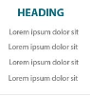

Figure 19 Footer Links Category Display Order



Figure 20 Footer Links Category Display Order

In order to display the Footer Link Categories and the Footer Links (of the Footer Links web part) in a specific order, a display order site column is required. The Display Order site column will allow a user to specify a numeric value which will indicate in which order a Footer Link Category or a Footer Link will be displayed.

|  |  |
| --- | --- |
| **Footer Links Display Order Site Column Information** | |
| Internal Name | FooterDisplayOrder |
| Display Name | Display Order |
| Field Type | Numeric Column with no decimals and a minimum value of 1. |
| Mandatory | Yes |

## Short Description

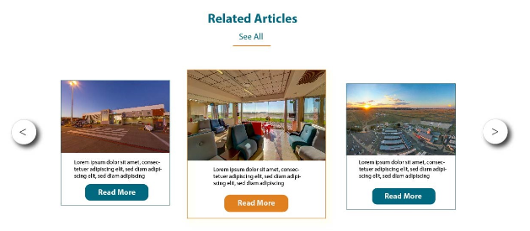

Figure 21 Important Message Short Description

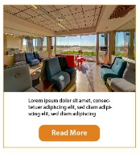

Figure 22 Latest News Short Description

Many of the web parts that will be created during the intranet implementation require a short description to be displayed (e.g. Important Message web part, Latest News web part, Announcement web part and the Bulletin web part). Because of the constant reuse, a reusable site column called Short Description will be created. The Short Description site column will be used by the Linked Summary content type. This site column will be used to contain multiple lines of text, but will not have rich text formatting.

|  |  |
| --- | --- |
| **Site** | **Column Information** |
| Internal Name | ShortDescription |
| Display Name | Short Description |
| Field Type | Multiple Lines of Text (Plain Text) |
| Mandatory | No |

# CONTENT TYPES

A content type is a categorised, reusable collection of metadata (site columns) and settings that can be attached to a list or document library. Content types enable management of the settings for a category of information in a centralized, reusable way.

Content types can be applied on any list or document library in the site hierarchy. When business requirements change, content types can be modified to meet the new requirements and push down the updates to any list or document library where the content type is used.

The following content types will be created to accommodate the functionality required by some of the web parts:

## Linked Summary

Across the Intranet site there are multiple instances where it is required to display items with the following attributes:

* A Title
* Redirect URL
* Short Description

To facilitate the need for these fields that get reused, the Linked Summary Content Type will be created.

|  |  |
| --- | --- |
| **Content Type Fields** | |
| Parent Content Type | Item |
| Count Type Group Name | Custom Content Types |
| Internal Name | LinkedSummary |
| Display Name | Linked Summary |
| Dependencies | SharePoint Publishing Features need to be activated. |

|  |  |  |  |  |
| --- | --- | --- | --- | --- |
| **Linked Summary Fields** | | | | |
| **Internal Name** | **Display**  **Name** | **Type** | **Mandatory?** | **Description** |
| **Title** | Title | Single Line of Text | Yes | Default SharePoint field inherited from the parent content type. |
| **LinkedSummaryRedirectURL** | Redirect  URL | Hyperlink or Picture | Yes | This field will contain the URL where the user should get redirected to. |
| **LinkedShortDescription** | Short  Description | Short  Description  Site Column  (Multiple  Lines of Text | No | This field will contain a short text description. |

This content type can be used whenever a title, description with a redirect URL is required within a list or document library.

# LIST TEMPLATES

List Templates contain the definition for a list or document library. The definition of the list templates contains the information required to create a new list with predefined columns (fields), and settings, and the list can even be populated with predefined list items.

The following list templates will be created to assist ACSA when creating lists that often have the same columns:

## Footer Links

The Footer Links List Template will be used to create a Footer Links list, which will contain all the required information to allow the Footer Links Web Part (see section 10.2.2) to display the links found in the footer of the Home master page and Sub Home master page.

|  |  |
| --- | --- |
| **Footer Links List Template Information** | |
| Internal Name | FooterLinks |
| Display Name | Footer Links |
| Content Type | Linked Summary |

The Footer Links List Template will inherit its fields from the Linked Summary Content Type. The following additional field will be added to the List Template:

|  |  |  |  |  |
| --- | --- | --- | --- | --- |
| **Footer Links List Template Fields** | | | | |
| **Internal Name** | **Display**  **Name** | **Type** | **Mandatory?** | **Description** |
| **FooterLinkCategory** | Category | Footer Link  Category  (See section  6.1) | Yes | Used to categorise footer links within the list. |
| **CategoryDisplayOrder** | Category  Display  Order | Display  Order (Site Column. See section 6.2) | Yes | Specifies the display order of the categories in the Footer Links web part. |
| **LinkDisplayOrder** | Link  Display  Order | Display  Order (Site Column. See section 6.2) | Yes | Specifies the display order of the categorised links in the Footer Links web part. |

The Footer Links List Template will inherit its fields from the Linked Summary Content Type. The following additional field will be added to the List Template:

# WEB PARTS

Web Parts are functional components that can be placed on a SharePoint page. Web Parts allow the authenticated users to alter the content, appearance, and behaviour of the web part; these alterations can all be made via any browser.

## Standard SharePoint Web Parts

SharePoint has a variety of built in web parts that allow users to display data stored in lists and document libraries on any page found within SharePoint.

This section will describe some of the standard SharePoint web parts, and specify where they will be used on the ACSA Intranet.

### 9.1.1. Lists and Libraries Web Part

The Lists and Libraries web parts allow users to place lists and/or document libraries that are found on the current site onto any SharePoint web page inside a page content area or inside a web part zone.

The data that is displayed by the web part can be modified by configuring the view of the web part. A predefined view could be used to display the data in the list or document library, or the web part’s current view could be modified to display the data in a different way.

The following common view configurations can be made:

* Which Columns are visible.
* The order the columns are displayed in.
* Which column to sort the items in the view by.
* The sorting direction (either ascending or descending).
* A filter can be applied to limit the items to display based on a predefined filter condition.
* The way the items are grouped together.
* An item limit can be specified. This will specify the number of items to display. If the amount of items in the list is more than the item limit, standard SharePoint pagination will be applied.

The title of the web part can be modified to suit the needs of the user. E.g. If you have a document library that contains procedure documents, the web part title can be set to display “*Procedures*”:

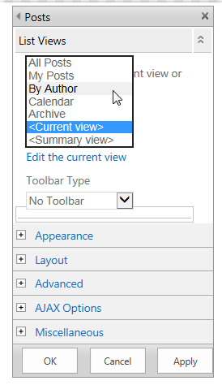

**Figure 23 Document List View Web Part with” Procedures” as a Web Part Title**

### 9.1.1.1 List View

The contacts list view will display the contacts in ascending order based on the username. The following columns will be based on the Internal Contacts List Template (see section 8.2).

When a user clicks on the username field of a list item, the user will get redirected to a page that contains all the users’ details. The details displayed will be the information retrieved from ACSA’s Active Directory service.

Active Directory service.

### 9.1.2 Document Library View

The following document library view will be available for ACSA to use on the department pages.

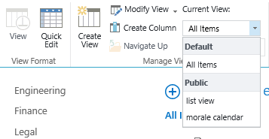

Figure 23 External News Document Library View Web Part

The external news document library view will display the latest 5 (five) external news documents. The documents will be ordered in descending order based on the date the document was uploaded.

### 9.1.3. Media Web Part

The SharePoint Media web part allows users with sufficient permissions to display videos found within an Asset library.

The Media web part optionally allows for display of an image whilst the video is not playing. The Media web part can be configured to start playing the video once the page has loaded completely. The Media Web Part can also be set to loop the video infinitely until the user decides the stop the video playback.

### 9.1.4. Latest Video Web Part

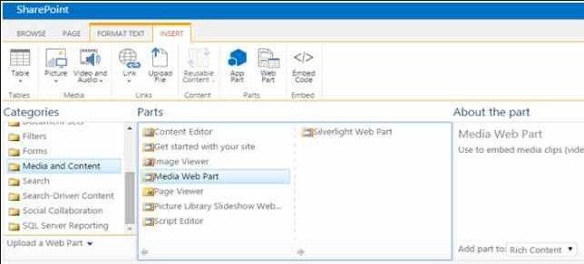

Figure 24 Latest Video Media Web Part

The Latest Video web part will be available to ACSA to display the latest videos on the home page of the intranet.

### 9.1.5. Content Editor

The Content Editor web part allows users to add rich (HTML) content into a web part zone.

Whenever content is required on a page, and there is no page content area available, a Content Editor web part can be used to inject content onto the page. The Content Editor web part also allows users to add images and hyperlinks into the content of the web part.

The following web parts on the home page are examples of Content Editor web parts being used to display content on a page

### 9.1.5.1 Content Editor

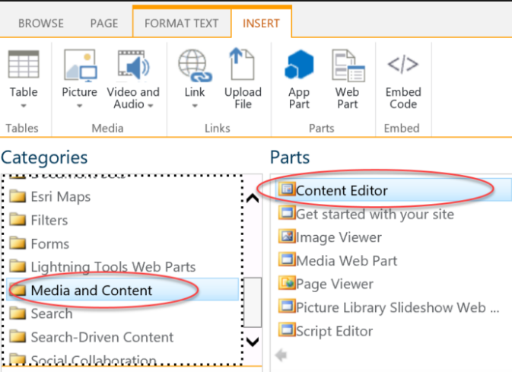

**Figure 26 Production Figures Content Editor Web Part**

The Production Figures web part is an example of how to use the content editor web part to display production figures content to the users. It will be the responsibility of ACSA staff members to specify the content that will get displayed in this section. Default styles from the ACSA design style sheets will be applied to the text content of this web part, unless ACSA makes use of the Content Editor’s built in text formatting capabilities.

### 9.1.5.2 Image Web Part

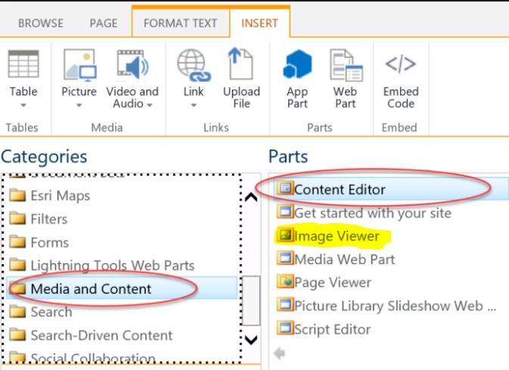

Figure 25 Content Editor Web Part

The Content Editor web part can be used to display images. In the above example we display the ACSA image.

The ACSA image will be uploaded into a Picture (or Asset) Library on the SharePoint site. The Content Editor web part will then be used to display the image on the home page of the Intranet site. Additionally, if ACSA wishes to do so, a hyperlink could be added to the image. If a hyperlink is added, users that click on the image will be redirected to the image that the hyperlink points to.

### 9.1.6. Summary Links (Quick Links)

The Summary Links web part allows users with sufficient rights to add grouped links into a page content area or into a web part zone.

When adding links to the Summary Links web part, the user can specify the text that should get displayed, the redirect URL of the hyperlink, an optional image to display with the hyperlink and if groups are added, the user can specify the group the hyperlink belongs to.

### 9.1.7. Content Query Web Part

The Content Query web part is a highly flexible web part that allows users to display content from a site, list, or document library. Once a data source is selected, the data from the data source will be displayed by the Content Query web part. The Content Query web part has configurable settings that allow a user with sufficient rights to change the data that gets displayed, and the way the data gets displayed.

The amount of results displayed can be changed by adding filters. There are three filters that can be added. The filters are based on values found in the fields (columns) of the document library, content type, list or site. In addition to filtering the data found in the data source, the Content Query web part also allows the grouping of results by a specified field (column), and it also allows the sorting of the filtered results in either ascending, or descending order.

When filtering results, the following three parameters must be specified:

1. The column to filter the results by: This could be any column that is available in a selected document library or list, therefore only columns that belong to the selected document library or list will be displayed in the drop down list.
2. The comparison filter type. This field will determine how the column value is compared to the filter value (explained below).

The following filter types are available:

* 1. Is equal to
  2. Is not equal to
  3. Is greater than
  4. Is greater than or equal to
  5. Is less than
  6. Is less than or equal to
  7. Begins with
  8. Contains

1. The filter value. This is the value that the value in the specified column will be compared to.

The resulting data that is displayed can further be manipulated by using XSL. XSL allows for an HTML structure to be defined, which can then be styled by a designer.

### 9.1.7.1 Latest News

The Latest News Content Query web part will be used on the Intranet home page, Complex home page and the Departments’ home page. As seen in the site taxonomy (section 4), a News sub site will be created in the home page site collection, and in each Complex site collection, and each Department sub site. The Latest News Content Query web part will read from the pages library of each of the News sub sites, and display the latest four (4) news articles by default. The number of news articles to be displayed can be configured in the Content Query web part’s properties.

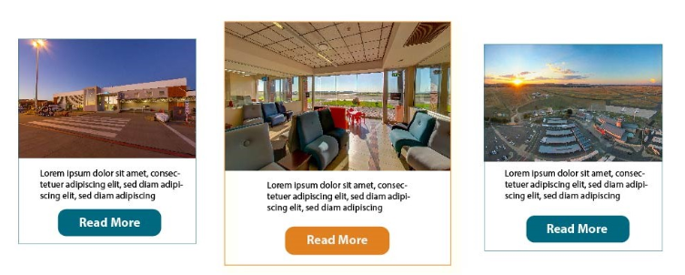

Figure 26 Latest News Content Query Web Part

The displayed news articles will be ordered by descending order, according the article date specified when the news articles is created.

The following values will be displayed by the Latest News web part:

|  |  |  |
| --- | --- | --- |
| **Values Displayed by the Latest News Content Query Web Part** | | |
| **Field Name** | **Type** | **Description** |
| **Image** | Publishing Image | The image added to the news article when it was created |
| **Title** | Single Line of Text | The title of the news article |
| **Short Description** | Single Line of Text | A short description of the article |
| **Article date** | Date and Time | The date of the article |
| **URL** | Hyperlink | The URL pointing to the Article Page |

When the user clicks on either the image, title or “Read More” button, they will be redirected to the news articles page.

At the bottom of the latest news articles there will be a “VIEW ALL NEWS” link. This link will point to the News sub site landing page.

## Web Parts Created for the ACSA Intranet

Custom web parts will be available globally in all site collections and will be developed once.

The following web parts will be developed.

### 9.2.1 Mega Menu



Figure 27 Mega Menu (Collapsed)

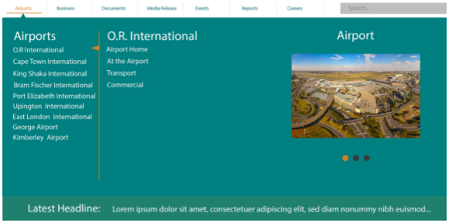

Figure 28 mega Menu (Expanded)

This web part will replace the standard SharePoint top navigation menu.

Three levels are defined for this menu:

* The Top Bar
* First Level Children
* Second Level Children

This web part will read navigation data from a list named “Mega Menu” in the root web site of the root site collection of the web application that hosts the site collections, which will be the ACSA site collection.

This navigation list will only be editable by the Intranet Administrator(s), and will need to be finalised by the ACSA Intranet Administrators in preparation for go-live. This menu is completely configurable and the example screen shot above is only an example of potential menu item entries, it is not indicative of the final navigation that the ACSA site will use.

The population of the list of navigation elements is the responsibility of ACSA. The current list items will be retained, but any additional elements must be added by ACSA.

### 9.2.2 Footer Links



Figure 29 Footer Links Web Part

The Footer Links web part will be used to display links in the footer of any master page that has a footer section. The web part will display the links grouped by their individual categories. The categories will be ordered ascending based Category Display Order. To the right of the category name, all links that belong to that category will be listed horizontally. The links will be ordered ascending according to the Link Display Order.

In the root of the current site collection, there will be a list called “Footer Links”, which will be based on the Footer Links List Template (see section 8.1). This list will be used to contain the links required to be displayed in the footer. Therefore, when a new page is added by the end user, the footer links web part will automatically display the links found in the “Footer Links” list, found in the root of the site collection.

The Footer Links web part will be configurable to allow a user with sufficient permissions to change the list that should be used to retrieve the links that get displayed by the Footer Links web part. Therefore, if the user doesn’t want to use the footer links found in the root of the site collection, another list can be selected.

### 9.2.3 Event Calendar

The events calendar will read from a SharePoint calendar and will bold dates which have events on them.

Today’s date will be emphasized by surrounding the date with a circle, and displaying it in orange.

Hovering over a bolded date will show the events for that day as a tooltip. The events in the tooltip will be clickable in order to show the SharePoint event item form for that event.



Figure 30 Events Calendar

The above calendar is a team calendar, it is not meant to be used as a personal calendar. It should ideally be used on the Intranet home page, Complex home pages or Department home pages to advertise events like a wellness day or world environmental day etc.

### 9.2.4 Image Rotator

The image rotator will read from a SharePoint photo library to display a new image every x seconds, where x is a configurable element of the web part.

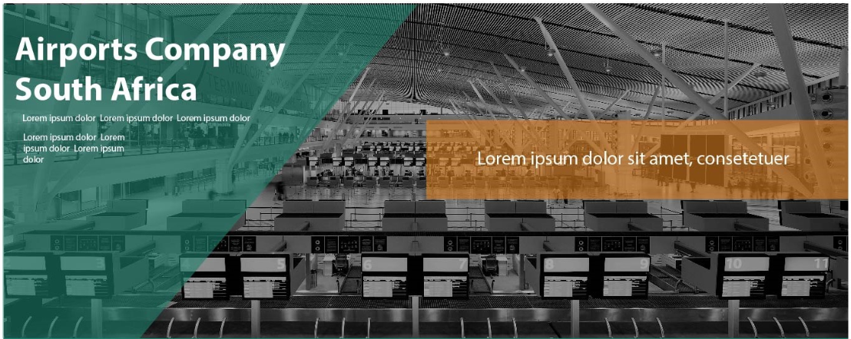

Figure 31 Image Rotator

During deployment, this time period will be set to 45 seconds. It may be adjusted by a SharePoint administrator at any time.

### 9.2.5. Important Message

The Important Message web part will display an important message that is found in a list called

“Important Message” which is found in the root of the current site collection. The “Important Message” list will have the following columns:



Figure 32 Important Message Web Part

|  |  |  |  |  |
| --- | --- | --- | --- | --- |
| **Important Message List Columns** | | | | |
| **Internal Name** | **Display**  **Name** | **Type** | **Mandatory?** | **Description** |
| **Title** | Title | Single Line of Text | Yes | Default SharePoint title field. |
| **Image** | Image | Hyperlink | Yes | A URL pointing to the image that needs to be displayed on the left of the Important message. |
| **URL** | URL | Hyperlink | Yes | A URL pointing to the content of the important message. This could be a link to a page, or a link to a document that contains the important message. |
| **ShortDescription** | Short  Description | Single Line of Text | Yes | A short description of the important message. |

If there is more than one important message in the “Important Message” list, only the latest created (not modified) message will be displayed by the Important Message web part.

If the user clicks on the image, title or the “Read More” button, the user will be redirected to the URL found in the URL field.

### 9.2.6. Announcements Scroller

The Announcements Scroller web part will be used on the home page of the intranet and optionally on the home page of a complex site. The web part will display the titles of the announcements found in the SharePoint Announcements list, found in the current site. The titles of the announcements will scroll from right to left.



Figure 33 Announcements Scroller Web Part

By default only the latest five (5) announcements will be displayed, but there will be a property available on the web part that will allow a user with sufficient permissions to configure the amount of items that will be displayed.

If a user hovers over the scrolling section of the web part, the announcements will stop scrolling until the users’ mouse leaves the scrolling section of the web part.

If a user clicks on the title of the announcement, a standard SharePoint modal pop-up window will appear. The modal pop-up window will display the properties on the announcement list item.

### 9.2.7. Most Visited Sites

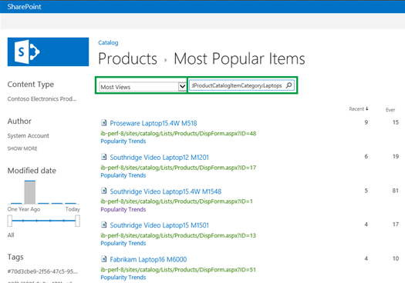

**Figure 36 Most Visited Sites Web Part**

The Most Visited Sites web part will use the SharePoint Usage and Health Data Collection Service information to determine the five (5) most visited sites within SharePoint. The five (5) most visited sites will then get displayed by the Most Visited Sites web part. If a user clicks on the title of one of the five (5) most visited sites, the user will then get redirected the that SharePoint site.

## Search

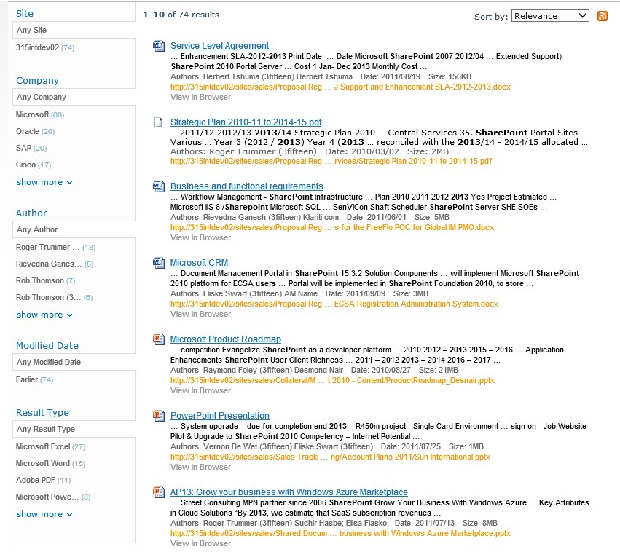

Figure 34 Sample Search Results Page

A user will be able to search for content, lists, list items, document libraries and documents by using the standard SharePoint search, on various levels:

* Library / List Level Search –this search is limited to only the documents in that specific library, or list items in that specific list.
* Web Site Level Search –this search is limited to only the content within that specific web site
* Site Collection Level Search –this search is limited to only the content contained within the specific site collection
* SharePoint Farm Level Search – this search is across all content across the entire SharePoint environment

SharePoint Enterprise utilizes a powerful search engine which allows the user to search across all site collections (farm wide search), within a site collection, within a web site contained in a site collection or even within a specific list or library.

Once a user has received a specific searched result, they may further refine their search by utilising the left hand refiner panel to narrow their search result even further by either author, result type (document, PDF etc.) or by any other metadata fields that apply to the content types that were returned by the search engine.

# ANNEXURE

## Menu Structure





